Linux - Grep

Project Description
In this task we
1. Find the error messages in the server_logs.txt file – various error message logs were found
2. Discover all files with the string “Q1” - 3 files associated with quarter 1
3. Discover all files with the string “access” - 4 files associated with user access for each quarter
3. Discover the deleted user jhill – this confirmed that jhill was deleted form the system
4. Discover the users that were added in Q4 – 2 users were added
5. Are generally awesome - and it's ok : )

Navigate To and Discover Logs Directory
We log into the CLI and navigate to the logs directory. We find the proper logs file and search for error messages using grep.

Command Semantics
    - cd /home/analyst/logs navigates to the directory “logs” (cd = “change directory”)
    - ls -la Populates the list of files and directories in the logs directory
          - ls WITH -l provides additional information about the files and directories listed such as permissions and owners.
          - ls WITH -a includes hidden files with the list of files and directories.
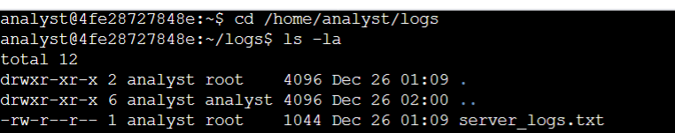

Search Logs File
Now that we are in the directory containing the proper file, and have discovered the directory. We can search using grep to discover error messages within the logs.txt file.

Command Semantics
    - grep error server_logs.txt searches the server_logs.txt file for the word “error”
    - grep <string> <file>
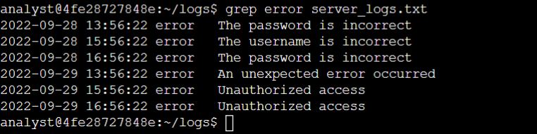

Search For Q1 Files in Users Directory
This task demands that Q1 files and directories be discovered in the users directory. We will use the nifty pipe command.

Command Semantics
    - cd /home/analyst/reports/users navigates to the directory “users” (cd = “change directory”)
    - ls | grep Q1 Populates the list of files and directories in the users (current) directory. | sends the output of the previous command to the next command: grep Q1 searches for the string Q1.

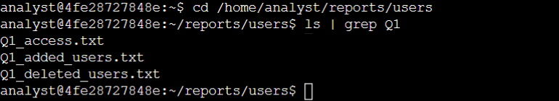

Discovering “Access” Files
We are looking for all “access” files in this task, in that same users directory.

Command Semantics
1.ls | grep access Populates the list of files and directories in the users (current) directory. | sends the output of the previous command to the next command: grep access searches for the string access.
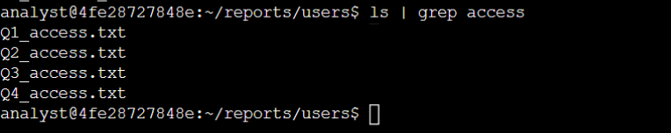

Discovering Deleted Users
In this task we discover the files in the users directory. Then, we discover the specific user jhill, to confirm they were deleted from the system.

Command Semantics
    - ls -la Populates the list of files and directories in the users (current) directory
          - ls WITH -l provides additional information about the files and directories listed such as permissions and owners.
          - ls WITH -a includes hidden files with the list of files and directories.
    - grep Q2_deleted_users.txt jhill this grep command searches the Q2_deleted_users.txt file for the string “jhill”
    - grep <string> <file>

NOTE: There is not a screen shot for this task here – the user jhill was discovered in the proper file

Discovering Q4 Added Users
This task demands the discovery of users added to the organization in Q4. That information can be found in the Q4_added_users.txt file in the users directory.
Command Semantics
    - grep “Human Resources” Q4_added_users.txt searches for the string “Human Resources” in the file Q4_added_users.txt
    - grep <string> <file>
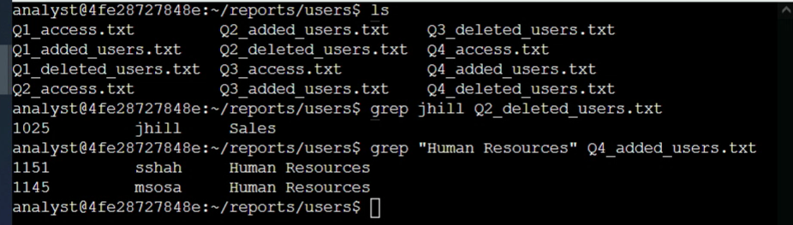

Summary
The tasks in this scenario are typical for a Cybersecurity engineer who is ensuring the hardness of the organization's security posture is up to snuff. We find error message codes such as “incorrect password entered”, discover various files associated with particular quarters, Discover files associated with user access, confirmed a deleted user was in fact deleted, as well as discovered all users added during Q4. And of course, throughout we endeavoredd to be awesome in a general sense. We did it! Wouldn't you say?

